Python A -- Course Content Summary

# Module A

## Markdown

* *** *** italic and boldface
* # ## ### {-}?
* ordered list

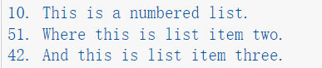

it will show below:

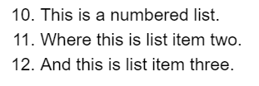

* span multiple lines

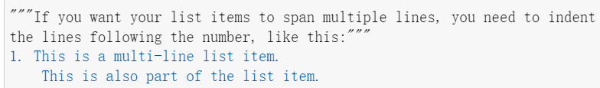

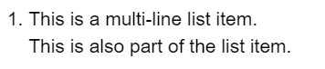

* unordered list

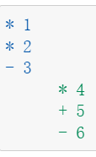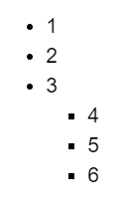

* Block Quotes >
* Verbatim text ???
* Link

This is a link to [my blog](http://www.mailund.dk).

others???

* image

![Title of the figure](URL-to-figure)

![Title of the figure](full path to/this_figure)

![local picture](C:\Users\T480S\Desktop\R_study\R_shortcuts.png) ？？？

* horizontal rules ***



* code block ””” ””” note: distinguish this triple quotation from that one under the edit mode

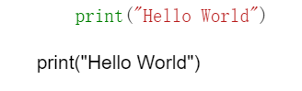

* Build table

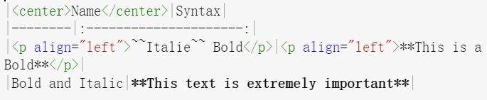

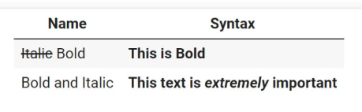

## 1.2 Variable

* Data types

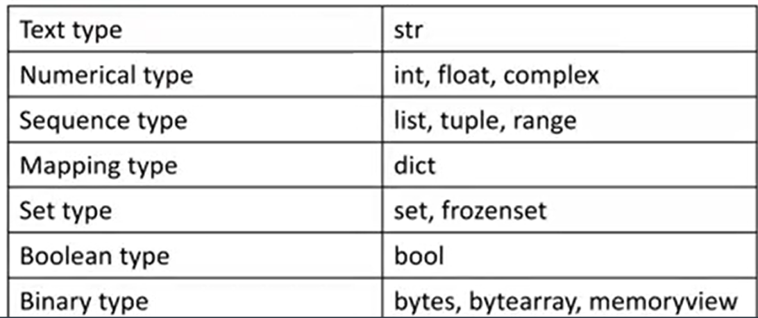

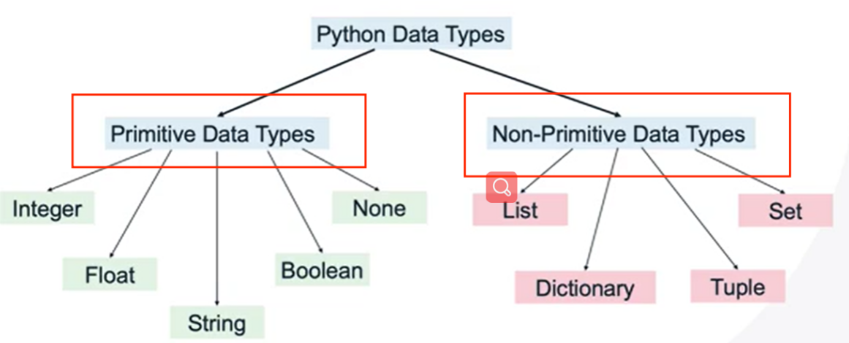

tip:

(1)from negative infinity to infinity

(2)only one type of integer

(3)a, b, c = 10, -5, 0 or a=10;b=-5;c=0

(4)unary operation +=

(5)precedence associativity

(6) ** is the highest priority. // % / * is the second priority. +- is the lowest one

* roundoff error

round(3.1415,2) output 3.14

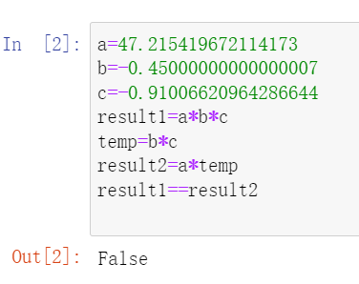

solution: set a threshold to detemine equality

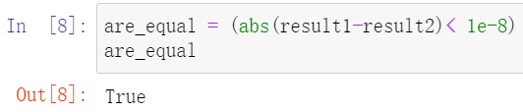

## 1.3 math & cmath (complex literial)

* from math import *
* dir() dir(math) shows all the functions in the math library
* factorial(3) 3!
* logyx math.log(x,y)

math.log(math.e) = 1 natural logarithm of the input argument math

也就是log()=ln()

* math.exp(x) math.log10(x) math.sqrt(x)
* math.ceil(x) math.floor(x)
* cmath.sqrt(-1)
* 1+2j == complex(1,2)
* decimal_part,int_part= math.modf(q8_num)

separate a number into fractional and integer part

## 1.4 random

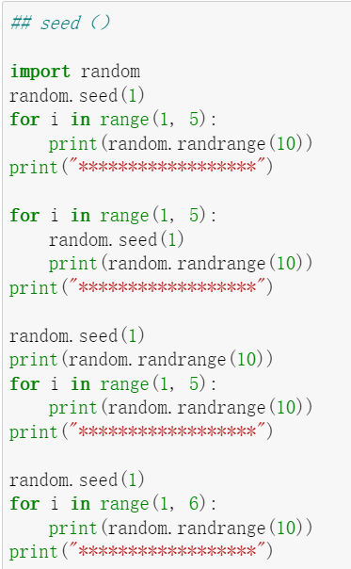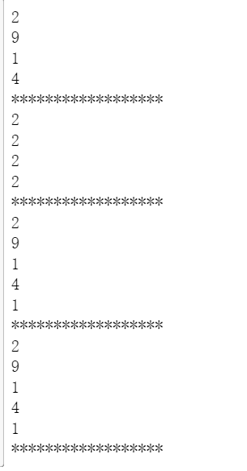

* random.uniform(-3.5,8.1)
* random.randint(-7,10) containing 7 and 10
* random.randrange(5,7,2)

random.randrange(start, stop, [step]) stop not inclusive

* random.choice([list]) select random elements from list ,tuple also be ok
* random.choices(a,k=6)
* random.choices(a,weights=[1,1,1,1,1],k=6), the weights of every element
* random.random() [0,1) float type

## 1.5 string

* note the difference between print(multipleStringLine) and multipleStringLine “““ ”””
* len(*string*) include blank spaces
* str1 = “bye! ”*3
* build-in function lower(),upper(),replace(x,y),count(x),isalpha(),capitalize(),title()

in, not in, swapcase()

* string.strip() .lstrip() .rstrip() #default leading character is blank space

txt = ",,,,,rrttgg.....banana....rrr"  
 x = txt.strip(",.grt")  
 print(x)

output: banana

* look for all the build-in function for string, stringvaribale. tab
* str1[0], str1[-1],str2[-3],str[1:2],s[-2:-1] = s[-2]
* str[2:2] or str[2:1] will give the result of ‘ ’
* str1[1:5:2] or str1[5:2:-2] the third arg is step
* Two special strings that can be converted to a floating point numbers are ‘inf’ and ‘-inf’, which represent infinity and negative infinity, respectively

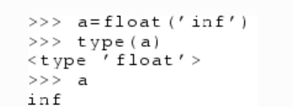

* the first% indicates the pattern start, 5 and -5 is left or right of string, the second% symbol is the argument to fill the pattern

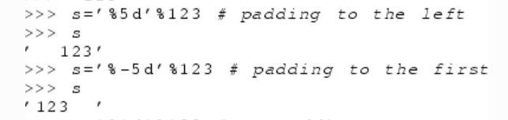

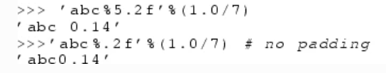

## 1.6 Quiz

(4) alt+ shift+ ctrl+ Enter

(11) Multi-line comments start with /* and end with */ it’s not right

help() ?math math?

(13)

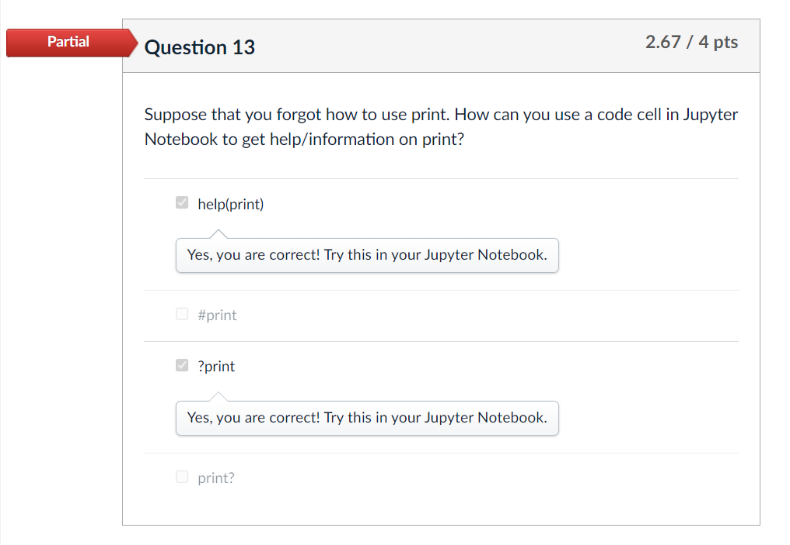

Question 20

What is the output of the following print() statement?

#named placeholders

txt1 = "My name is {fname}, I am {age}".format(fname = "John", age = 9)

#empty placeholders

txt2 = "My name is {}, I am {}".format("David", 12)

#price inside named placeholder

txt3 = "The price of John's toy is only ${price:.2f}".format(price = 49)

#price inside empty placeholder

txt4 = "The price of David's toy is only ${:.2f}".format(99.1212)

print(txt1, txt2, txt3, txt4, sep = '. ')

Note that the format() formats the specified values and insert them inside the given placeholders. The placeholder is defined using curly brackets: {}.

Q23

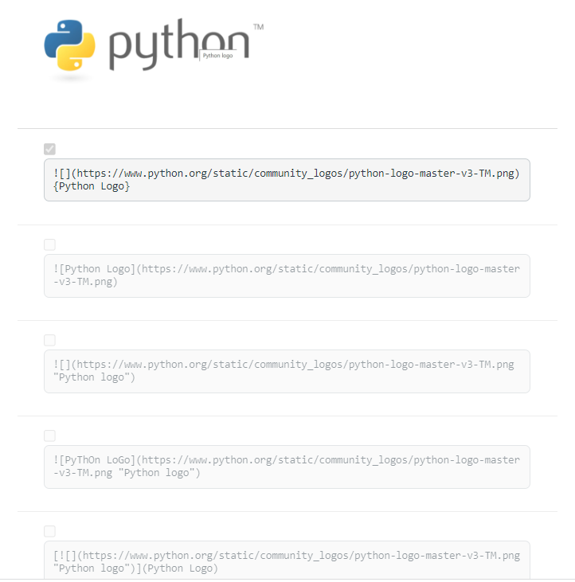

## 1.7 assignment

## 2.1 = cascaded

person1_age = 50

person2_age = 30

same_age = person1_age=person2_age

print(same_age) output 30

## 2.2 logic expression

* a>b and b>c or b>c and c<a

and has higher priority than or

* 1 < 2 < 3 is interpreted as 1 < 2 and 2 < 3

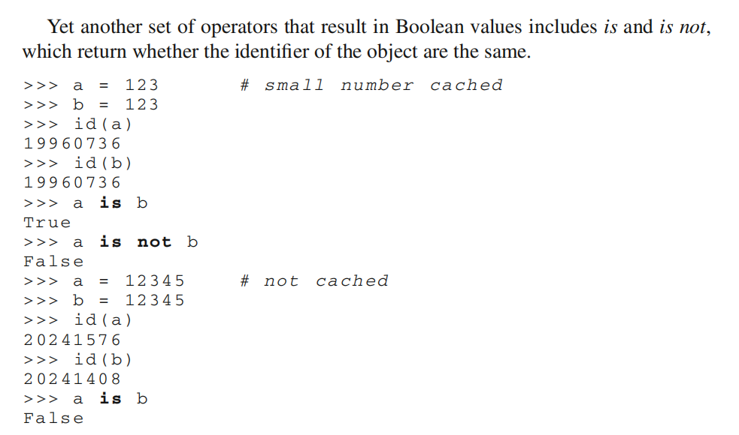





## 2.3 eval(“1+1”) output :2

eval() parse the expression within the parenthesis and run it in the python.

## 2.4 isinstance()

isinstance(3, (int, float))

returns True if the object is an instance of the class or of a subclass of the class. It can also take a tuple of classes, in which case it returns True if the object is an instance of any of the classes in the tuple.

## 2.5 assert

* assert user_input.isdigit() == True, "User's input is not numbers"

Python isdigit() 方法检测字符串是否只由数字组成，只对 0 和 正数有效。

* assert isinstance(user_input, int), "Have not converted the input() to int"

## 2.6 logging

logging.basicConfig(level=logging.INFO, format='%(asctime)s-%(filename)s[line:%(lineno)d]-%(levelname)s:%(message)s',

#datafmt = '%H:%M:%S',

filename='LOG//workshop.log',

filemode='w')

* the style of LOG message

{LEVELNAME}:{NAME}:{MESSAGE}:{ASCTIME}:{FILENAME}:{FUNCNAME}:{LINENO}

* logging.DEBUG output : 10 get relevant log level number

logging.levelToNumber[10] output: DEBUG convert relevant level number to level name

## 2.7 Assignment

question8: decimal_part,int_part= math.modf(q8_num)

question15: equilateral, isosceles or scalene.

question17: isinstance(x,int)

isinstance(q17_variable,complex)

isinstance(my_value, type(None))

# 3 While Loop

strip()删除首尾字符

lstrip(‘a’)删除左侧带有的a的字符

rstrip(‘\n’)删除右侧的\n

# 4 list and dictionary

## 4.1 list

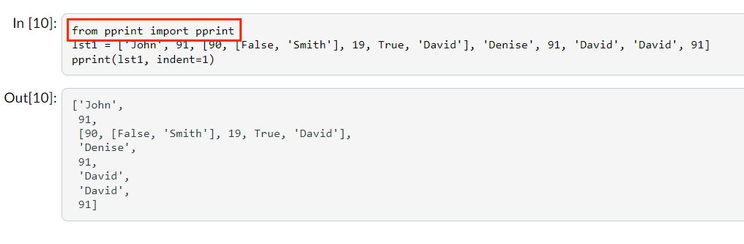

增操作：

list1+list2

list1*2

list.insert(index,[1,2,3])一次只能增加一个操作在相应的index，如果想要插入多个元素

my_list = my_list[:2] + [6, 7, 8] + my_list[2:] 或者如下所示。

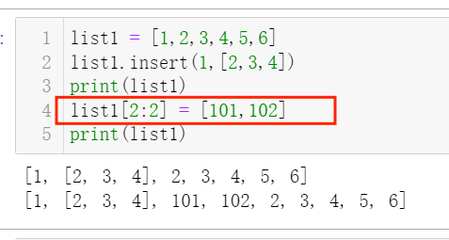

append() and extend(), append(“element”) argument is element, list1.extend(list2) argument is list, list3 = list1+list2 it will creates a new list, extend()will change original list.

删操作：

1. list.remove() remove the first matching element in a list, If the element is not in the list, the method returns an error.

#while方法去除“”值

q13_list =[37, 60, 41, 30, "", 15, 59, "", "", 76, 79, 91]

while "" in q13_list:

q13_list.remove("")

1. list.pop() it will remove the last element in the list and return the element.

list.pop(1) remove and return an item at a specified index

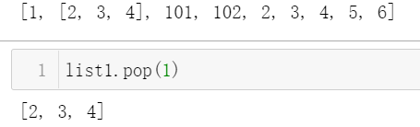

pop() method can be used with a dictionary to remove and return a value associated with a specified key dict.pop(“key”)

1. del list[1], del list[1:3], del list
2. list.clear()

查操作

1. 一个元素是否在list

element in list1; not in

1. list[1] 与list.index(1)区别

前者是查询1位置的元素是多少，后者是查询元素为1的数 在list中的位置是多少。

1. list.copy()
2. sort()

.sort()方法会直接对原始列表进行排序，并将其改变为已排序的列表。如果需要原始列表保持不变，可以使用sorted()函数来创建一个新的已排序的列表。

需要注意的是，sorted()函数适用于所有可迭代的对象，而.sort()方法只适用于列表。

d = {'a': 1, 'c': 3, 'b': 2}

sorted_dict = dict(sorted(d.items(), key=lambda x: x[0]))

print(sorted_dict)

lst = [('Earth', 149.6), ('Jupiter', 778.5), ('Mars', 228.0), ('Mercury', 57.9), ('Neptune', 4515), ('Saturn', 1432), ('Uranus', 2867.0), ('Venus', 108.2)]

# 使用 lambda 函数指定排序关键字为第二个元素,由大到小排列。

lst.sort(key=lambda x: x[1],reverse = True)

key的前提是针对list里的元素说的，这一题lst的element是tuple，那么排序的主体就是tuple，也就是lambda x 里的x所表示的对象，x[1]就是根据tuple第二值进行排序。

同理lst[‘key’,’wwe’,’Kkk’]

lst.sort(key=str.upper,reverse = True)

lst元素是string，那么排序主体就是string，所以key=str.upper.

a = lambda x：x+1 a(10) = 11

1. list.reverse() list = list[::-1]
2. list.count(“string”) 计算个数
3. lst = [1, 2, 3, 4, 5, 6, 7, 8, 9, 10]

# 使用lambda表达式定义过滤函数

filtered_lst = list(filter(lambda x: x % 2 == 0, lst))

print(filtered_lst)

# [2, 4, 6, 8, 10]

需要传入一个函数和一个序列作为参数，函数用于对序列中的每个元素进行判断，如果返回值为True，则保留该元素，否则过滤掉该元素。

## 4.2 dictionary

Initialization of two style

age1 = {"John":52, "Siobhan":21, "Ye":18}

age2 = dict(John=52, Siobhan=21, Ye=18)

key type(s) you choose must be immutable.

增操作：

my_dict = {'a': 1, 'b': 2}

# 添加新的键值对

my_dict['c'] = 3

my_dict.update({’c’:3})

# 使用字典推导式添加多个键值对

new_dict = {k: k.upper() for k in ['c', 'd', 'e']}

# 将新的键值对合并到原始字典中

my_dict.update(new_dict)

dict1 = {'a': 1, 'b': 2, 'c': 3}

dict2 = {'d': 4, 'e': 5, 'f': 6}

zipped = zip(dict1.keys(), dict2.values())

print(dict(zipped)) 这里zip只是两两配成元祖，前面可以加dict，list，tupe，list（zipped）都可以转换为相应类型。

删操作：

del dict[‘a’] pop[‘a’] 都能删除键值对，但是pop返回值

#删除多个键值对

keys_to_delete = ['a', 'c'] # 生成新字典，不包含要删除的键值对

new_dict = {key: value for key, value in my_dict.items() if key not in keys_to_delete}

dict.clear()

查操作：

查一个key是否在dict里 if key in dict not in

查一个value是否在dict里 if ‘Alice' in dict.values() not in

.keys() .values() 返回的是列表

.items()返回的是键值对元祖的列表

改操作：

repr( ) returns the string representation of the dictionary

repr(dictionary)

# 5 function

## 5.1 scope of variable

* What happens if you have the same variable name in the main body of the program and also inside of a function? See the example below. In such instances, Python will treat them as two separate variables; one in the main body of the program belongs to the global scope and the other inside the function belongs to the local scope.
* Python has the global keyword, if you want to make a variable global. Therefore, you can use the global keyword in a function body to create a global variable to make it accessible outside of the function

## 5.2 side effects in function

* if the input parameter is immutable type, the function will create a new local variable inside function, but the same name variable outside the function will never be changed.

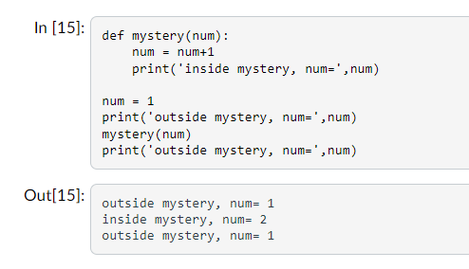

* however, if the input parameter is mutable type ,like list, the list variable will be changed outside.

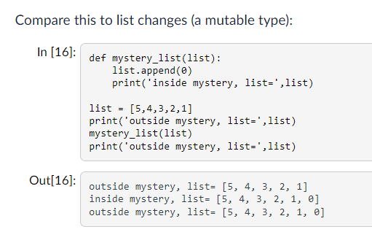

def swap_list(list1, list2):

temp = list1

list1=list2

list2=temp

list1=[1,2,3]

list2=[4,5,6]

swap_list(list1,list2)

print(list1,list2)

output: [1, 2, 3] [4, 5, 6]

尽管上个例子list.append(0),改变了outside list的value。但是下边代码尽管参数是可变的list类型，用“=”赋值操作依然不会改变原数值，因为使用“=”就会函数内部创建local value。Notice that in the mystery_list function there is no assignment. There is no '='. The use of '=' creates a new variable local to the function.结论： function should only access values from the parameters or change only mutable parameters using the functions (rather than assignment)

## 5.3 parameter and argument

* 1. parameter是指函数定义中参数，而argument指的是函数调用时的实际参数。

1. 简略描述为：parameter=形参(formal parameter)， argument=实参(actual parameter)
2. Parameters (values passed to a function) Arguments (the values used when actually calling the function, that is assigned to the function’s parameters)
3. you will have to arrange all your default parameters after non-default parameters.
4. Keyword Arguments:

keyword arguments, they do have to come after positional arguments and before default arguments in a function call

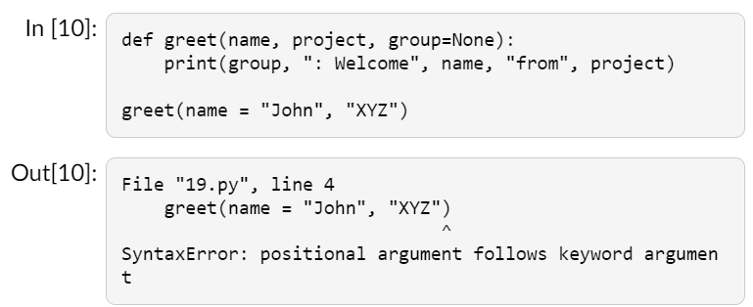

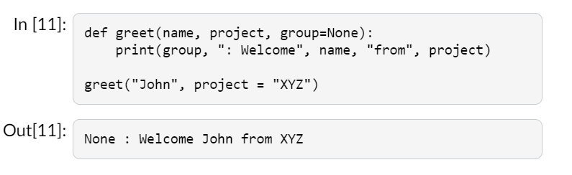

## 5.4 Variable Number of Arguments

* The single * will place all of the values into a *tuple* (It is an immutable list)

The second option (**) will place all of the values into a *dictionary*

*return args -> tuple*

*return kargs -> dictionary*

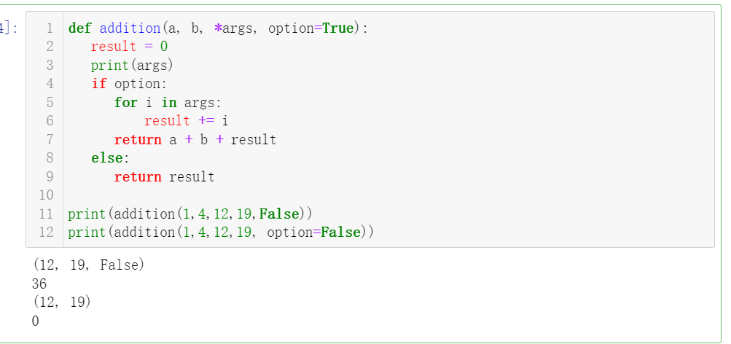

这个例子给args赋值最后是FALSE是赋给args，如果想给option赋值，这时必须key argument to it like option=False.分

## 5.5 anonymous function

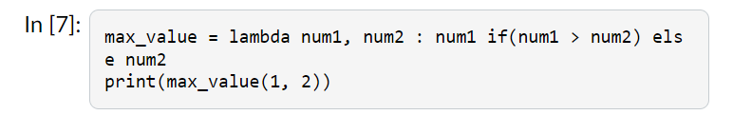

quiz:

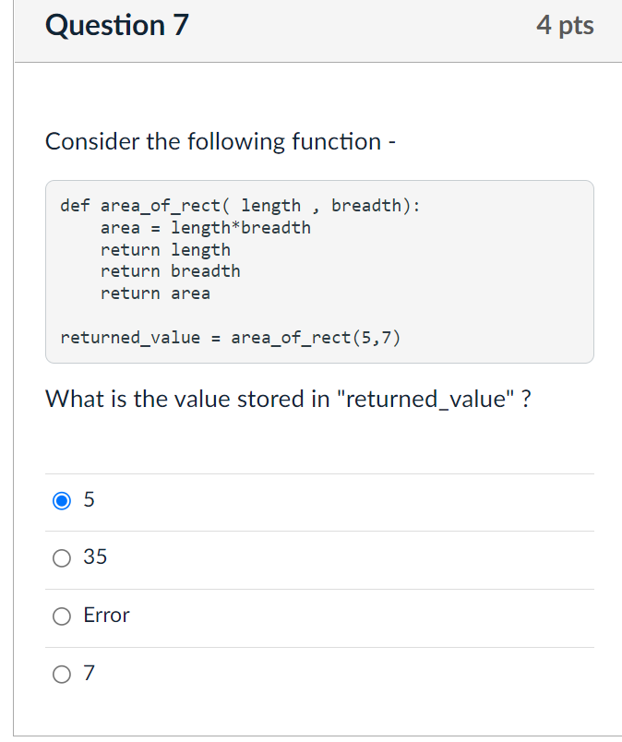

第一个return就退出函数了，后两个return就没有运行。

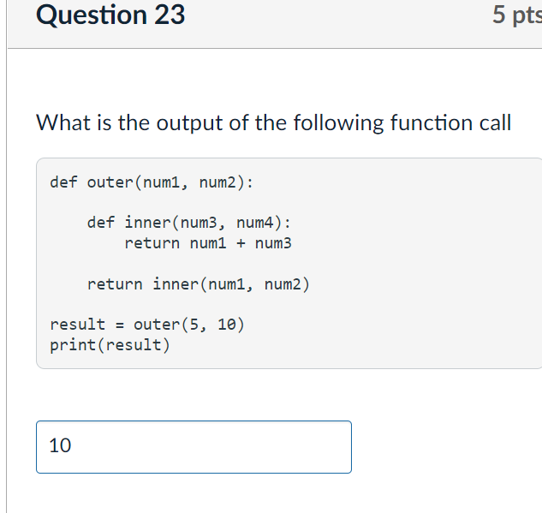

# 6 tuple and string

## 6.1 string index

str1.index('LLO', 2, 6)从位置2开始到位置5之间找，不包括6

str1.find('lLO'，2)从位置2开始到结束之间找

rindex，rfind从尾部开始找

find will return -1, if it can’t find the substring.

要想获取多个字符串的位置，只能自己编函数。

str1[-3: ]-> LD!

str1[-6:-1]-> WORLD

txt.split() default is space

lst2 = txt.split(", ", 2), maxsplit number is 2

### Joining an iterable into one String

"#".join(list1) or “%”.join(string) join(list) join(tuple) join(set), will be

ok, however, join(set) can’t guarantee the order because set is unordered

listNumbers[0:-1]#get all the elements except the last one

listNumbers[-3:] #get the last three elements

listNumbers[::-1] #reverse the list

listNumbers[10:0:-1] #reverse the list at the specific index

If you insert more elements than you replace, the new elements will be inserted where you specified, and the remaining elements will move accordingly. However, the length of the list will change when the number of elements inserted doesn't match the number of elements replaced.

Similarly, if you insert fewer elements than you replace, the new elements will be inserted where you specified, and the remaining elements will move accordingly. Once again, the length of the list will change. pay attention：both 20.1 and 5 are replaced by 9

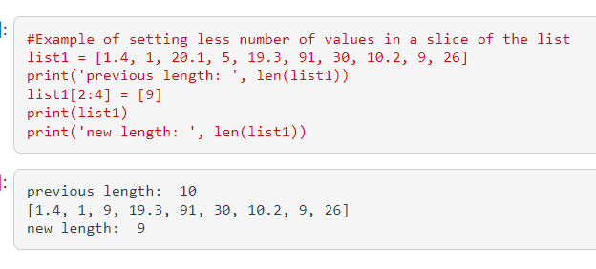

insert(index, element)

colors.insert(3,'green') insert函数只能插入一个值如果想插入多个值，得用切片。

my_list = my_list[:2] + [6, 7, 8] + my_list[2:]

A list has several methods that allow you to change it: append( ), insert( ), sort( )... strings have none of these. You can't change a string once it's created. Of course, you can reassign the variable to a different string:

[*item* for *item* in *iterable*]

[*item*  for *item* in *iterable* if *condition* == True]

if-else

lst1 = ["even" if i%2 == 0 else "odd" for i in range(10)]

the placement of the "if" statement depends on whether you want to filter the values generated by the loop or conditionally assign values to the list elements.

如果产生的值是for-loop形成的，那么for就在前面，如果产生的值是if形成的，那么if就在前面

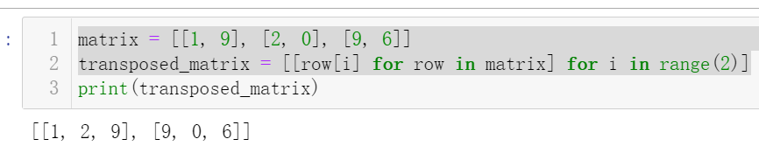

## 6.2 tuple

函数返回多个值，这些值的组合就是tuple.

Tuple elements are ordered, indexed, unchangeable, and allow duplicate values. Tuple elements can be of any data.

If you want to have a tuple with only one element.

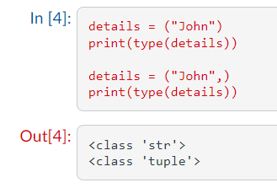

the [:-1] slice specifies that we want to include all elements of the list from the beginning up to, but not including, the last element.

 tuple('abc') returns ('a', 'b', 'c') and tuple( [1, 2, 3] ) returns (1, 2, 3)

but tuple({'abc'}) returns(‘abc’,)

（“abc”，）带逗号才能表示一元元组。

拆包：

t = (1,2,3,4)

a,b= t[::2]

output: a=1，b=3

连接：

t1 = (1,2);t2 = (3,4)

t3 = t1+t2

t3 = t3[:2]+(10,)+t3[2:]

output: (1, 2, 10, 3, 4)

## 6.3 set

在Python中，集合（set）是一种可变的无序集合，它是由一组互不相同的元素组成的，具有去重的特性。集合是一种非常实用的数据类型，在处理数据时能够快速实现去重、判断元素是否存在等功能。下面介绍一下set的增删改查操作。

增加元素：

可以通过add()方法向set中添加单个元素，也可以通过update()方法向set中添加多个元素。

pythonCopy code

# 创建一个空集合

my_set = set()

# 使用 add() 方法添加单个元素

my_set.add(1)

# 使用 update() 方法添加多个元素

my_set.update([2, 3, 4])

print(my_set) # 输出结果：{1, 2, 3, 4}

删除元素：

可以通过remove()方法删除set中的元素。如果要删除的元素不存在，会抛出KeyError异常。还可以通过discard()方法删除元素，如果元素不存在，不会抛出异常。

pythonCopy code

my_set = {1, 2, 3, 4}

# 使用 remove() 方法删除元素

my_set.remove(3)

print(my_set) # 输出结果：{1, 2, 4}

# 使用 discard() 方法删除元素

my_set.discard(5) # 不会抛出异常print(my_set) # 输出结果：{1, 2, 4}

修改元素：

set中的元素是不可变的，因此无法修改单个元素。如果要修改set中的元素，需要先删除原来的元素，再添加新的元素。

pythonCopy code

my_set = {1, 2, 3, 4}

# 先删除原来的元素，再添加新的元素

my_set.remove(3)

my_set.add(5)

print(my_set) # 输出结果：{1, 2, 4, 5}

查询元素：

可以通过in关键字来判断一个元素是否在set中存在。

python Copy code

my_set = {1, 2, 3, 4}

if 3 in my_set:

print('3存在于集合中')

else:

print('3不存在于集合中')

| (union operator): The union operator is used to combine two sets into a single set that contains all the elements of both sets, without duplicates. For example, if A = {1, 2, 3} and B = {2, 3, 4}, then A | B = {1, 2, 3, 4}.

& (intersection operator): The intersection operator is used to find the common elements between two sets. In other words, it returns a set that contains only the elements that are present in both sets. For example, if A = {1, 2, 3} and B = {2, 3, 4}, then A & B = {2, 3}.

(difference operator): The difference operator is used to find the elements that are in one set but not in another. For example, if A = {1, 2, 3} and B = {2, 3, 4}, then A - B = {1} and B - A = {4}.

^ (symmetric difference operator): The symmetric difference operator is used to find the elements that are in either of the sets, but not in both. In other words, it returns a set that contains only the elements that are present in either A or B, but not in both. For example, if A = {1, 2, 3} and B = {2, 3, 4}, then A ^ B = {1, 4}.

(proper subset operator): The proper subset operator is used to determine whether one set is a proper subset of another. In other words, it returns true if all the elements of set A are also present in set B, and B contains at least one element that is not in A. For example, if A = {1, 2} and B = {1, 2, 3}, then A > B is false, but B > A is true.

< (proper superset operator): The proper superset operator is used to determine whether one set is a proper superset of another. In other words, it returns true if all the elements of set B are also present in set A, and A contains at least one element that is not in B. For example, if A = {1, 2} and B = {1, 2, 3}, then A < B is true, but B < A is false.

## 6.4 list comprehension

matrix = [[1, 9], [2, 0], [9, 6]]

transposed_matrix = [[row[i] for row in matrix] for i in range(2)]

print(transposed_matrix)

#先执行 for i in range(2)在执行括号里的

output： [[1, 2, 9], [9, 0, 6]]

transposed_matrix = [row[i] for row in matrix for i in range(2)]

print(transposed_matrix)

#先执行前面的for，后执行后面的for

output：[1, 9, 2, 0, 9, 6]

transposed_matrix = [row[i] for i in range(2) for row in matrix]

print(transposed_matrix)

#先执行前面的for，后执行后面的for

output：[1, 2, 9, 9, 0, 6]